**A Quick Look into Some Suicide Statistics**

By: Chingyi Ie, Richard Yim

**Overview**

In order to figure out some trends in global suicide rates, we looked at the “Suicide Rates Overview 1985 to 2016” dataset from Kaggle.com. We then took a look into suicide trends in the US along with some other economic factors.

**Suicide Dataset Trends/Insights**

We first decided to take a quick look at the total suicide numbers for each year. However, since some countries have missing data for some years, it would be difficult and inaccurate to compare the world’s total suicide rate progression over the years, as the lack of data for some countries would result in a lower value for some years than we would expect. Hence, we decided to take a look at the suicide rates in the United States alone.

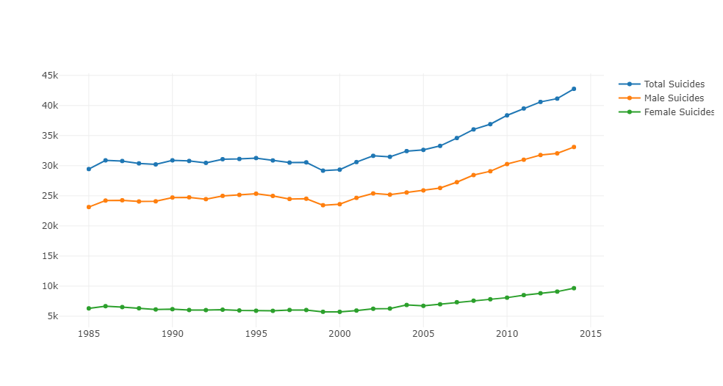

Fig 1: Total Suicide Numbers Over the Years in United States

As we see, total suicides in the United States seem to be relatively constant over the years 1985 to 2002, before a steady increase from 2003 to 2014. The figure above also shows a huge gap in suicide rates for male and females, as male suicides numbers seemed to be always higher than female suicide numbers.

This prompted us to further investigate the relation of sex and suicide rates. To do this, we decided to investigate by age groups. We first did an overall examination of total suicide numbers per age group.

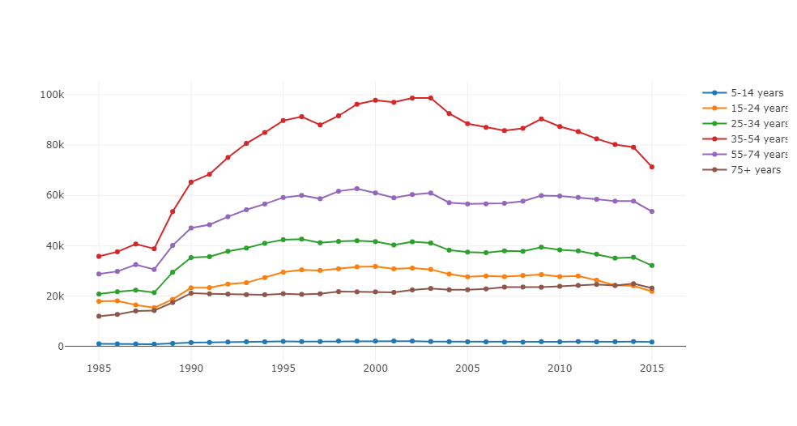

Figure 2: Total Suicides per Age group

Here, we are using the total data for the world, and while some countries contain missing data for the years, no missing data is found for the age groups nor sex, and hence will not make the comparison inaccurate. In Figure 2, we see that total suicide numbers are highest for ages 35-54, and lowest for ages 5-14.

We then did an examination of male and female suicide rates per age group. To focus purely on the rate of suicide and not the overall numbers, we decided to normalize the data to between 0 and 1, in order to better see trends in suicide rates.

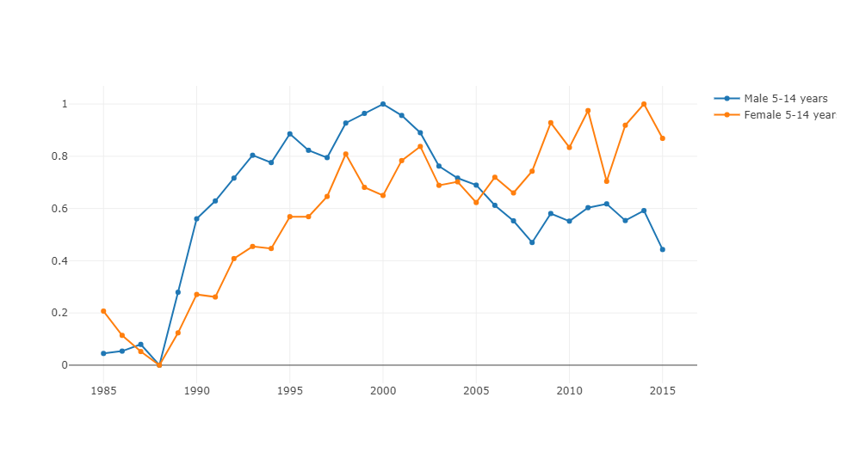

Figure 3: Male vs Female Suicide Rates for ages 5-14 years

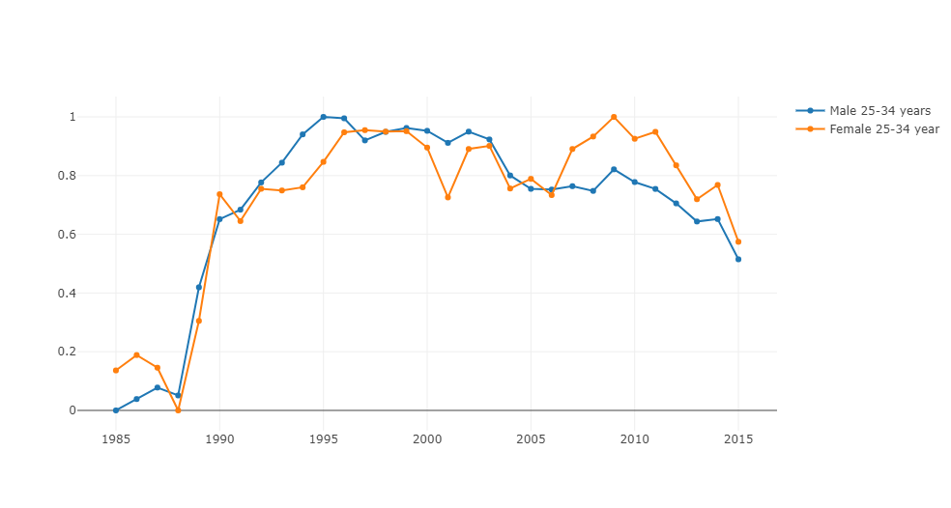

Figure 4: Male vs Female Suicide Rates for ages 25-34 years

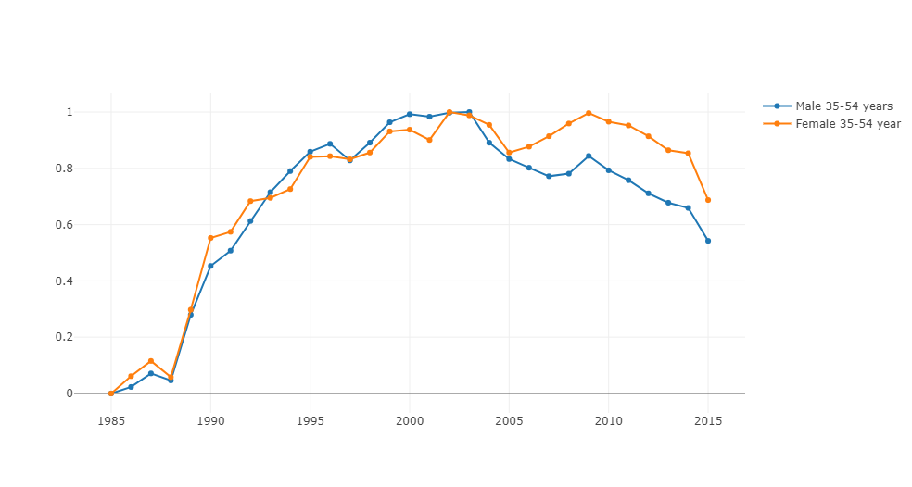

Figure 6: Male vs Female Suicide Rates for ages 35-54 years

Through this investigation we found an interesting yet disturbing trend, which is that in recent years, the change in the rate of suicide for females is actually higher than that of males for people below the age of 55 years! A look at figures 3,4,5,6 will show that the change in female suicide rates have surpassed that of males starting from around 2003 to 2008.

A quick look at the data for United States also show a similar rising trend for female suicides, especially in females from ages 5 to 34. Females of those ages show an increasing suicide rate which became the same or even higher than that of males, even though their rates used to be far below that of males. We see an example of this in figure 7 below.

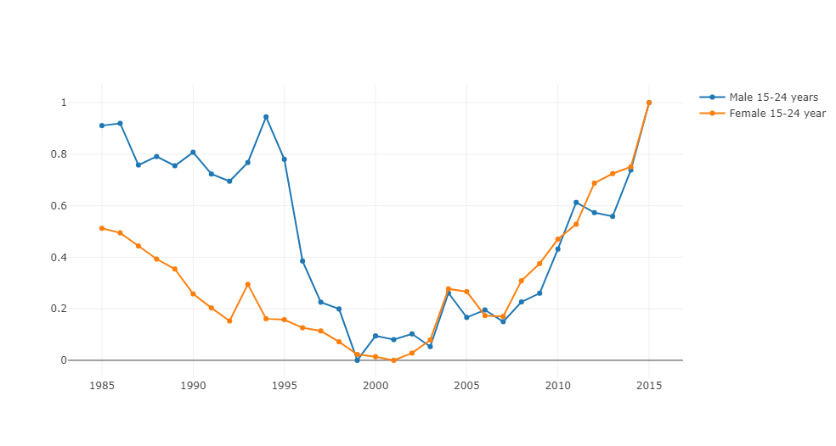

Another interesting trend we found is that females in the United States above the age of 75 have way higher suicide rates than males until very recently.

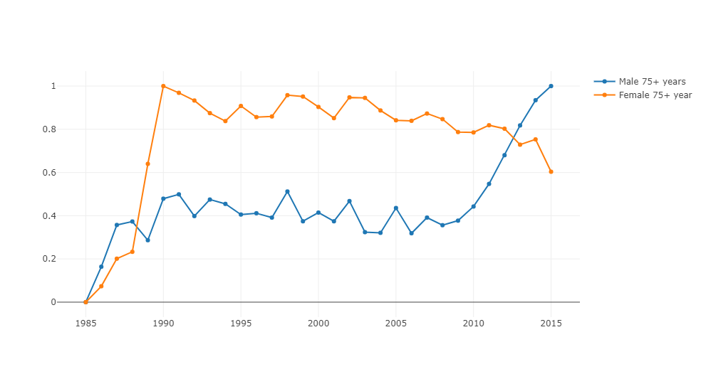

Figure 8: Male vs Female Suicide Rates in the US for ages 35-54 years

From figure 8, we see that the first jump in suicide rates occurred around 1990, and the huge gap in suicide rates continued all the way until 2013. Hence we see that although overall males have higher suicide numbers than females, when looking at the change in rates itself, females are actually increasing at a higher rate than men, which means that increase in the number of females that commit suicide are actually much higher than that of men.

***We now take a look at year over year suicide rates in the United States per gender as well as factors of unemployment and enrollment rates of students K-12.***

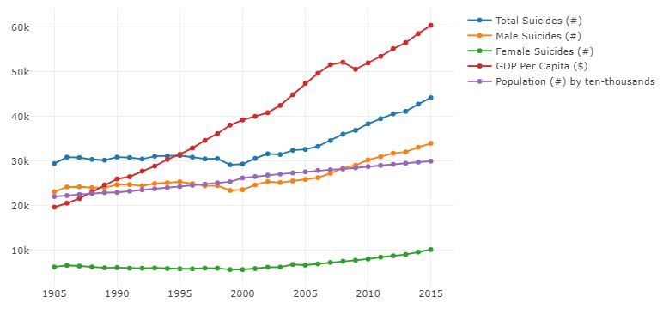

Figure 9: Total, Male, Female, GDP per Capita

We observe an interesting increase of suicide rates year over year starting 2000. We can see that although the population increase has been occurring throughout the late 1900s and early 2000s, there is an obvious increase in suicides in the US beginning in the 1999. Also, note that regardless of the increase in GDP per capita, suicides have been steadily increasing at a pace greater than population growth.

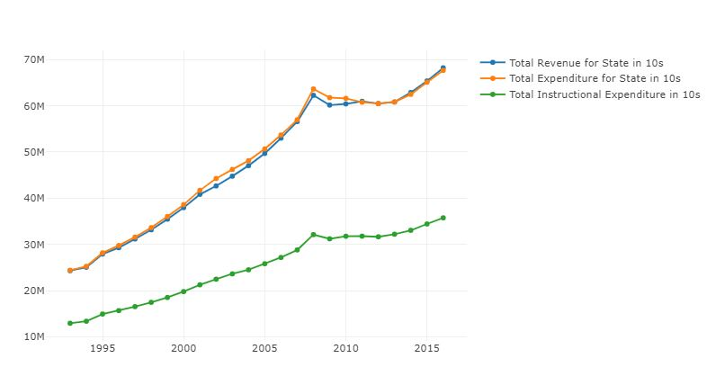

Figure 10: Total Revenue, Expenditure, Instructional Expenditure

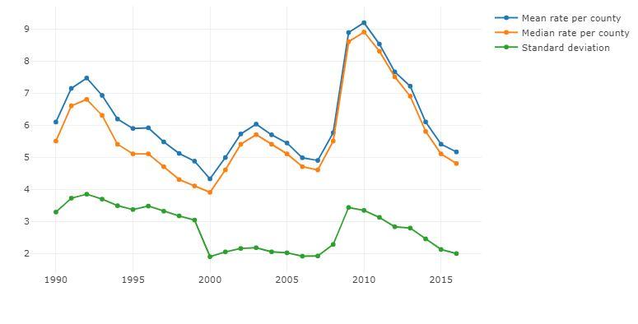

Figure 11: Mean, Median, and Standard Deviation of Unemployment Rates by County

In addition to Figure 9, we have in Figure 10 and 11 charts representing year over year spending in education by the government and rates of unemployment for the average and median US county, respectively. We can see a base support of the county unemployment rate increasing from 2000 to 2015, with a mostly small standard deviation from the mean. In addition we can see an increase in total expenditures by the government increasing in face of the increasing unemployment rate by county.

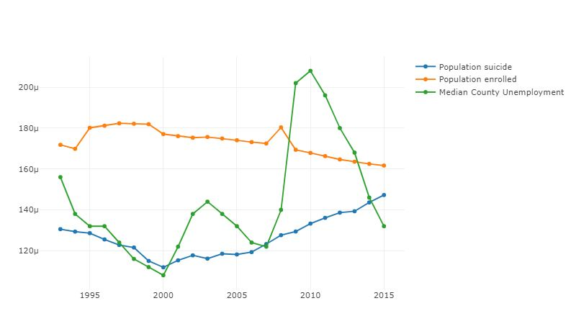

Figure 12: Population Suicide, Population Enrolled, Median County Unemployment

In this final chart we combine the overall trends of population suicide rates, population enrollment rates, as well the median county unemployment rate. Interestingly enough, we see than population suicide rates seem to correlated with increases in unemployment rates by county. Observing the infimum rate from 2000 to 2015, we see a baseline increase in median county unemployment supported by a trendline support of the population suicide rate year over year. The plot was generated by scaling the enrollment rate by a factor of 1000. The median county unemployment rate was scaled down by 50,000 and pushed up by 0.0003. The purpose was to simply visualize the trend and relationships between unemployment, suicide, and enrollment rates in the US year over year from 1993 to 2015.

Conclusion: Globally we are seeing a slight decrease in suicides, yet we see a general increase in suicide rates across the board from 1993 to 2015 in the United States. Moreover, the dominance of suicides per gender has been overtaken mostly by females across all age groups starting around 2005; however, for suicides over the age of 75, males are make up the majority of the victims. Finally, we see that with the baseline rise in median county unemployment in the US the rate at which the percentage of the population committing suicide year over year has increased as well.

Logistically, there are gaps across the board for all datasets. Aside from the gaps of data, we wished there would’ve been some attributes left out, and others left it. If we were to do a more in-depth analysis of suicide in the US for example, along with the unemployment rates and enrollment rates of states, it would have been ideal to have suicide rates per state in the United States. In future projects we wish to acquire more advanced statistical techniques to do better data analysis, though this is a more long term goal.

Sources for datasets:

<https://www.kaggle.com/jayrav13/unemployment-by-county-us>

<https://www.kaggle.com/szamil/who-suicide-statistics>

<https://www.kaggle.com/noriuk/us-education-datasets-unification-project>